PLEASE NOTE:

The highlighted boxes need to be INITIALED.
X’s will not be accepted by the facility.

Please see the instructions on the following page.
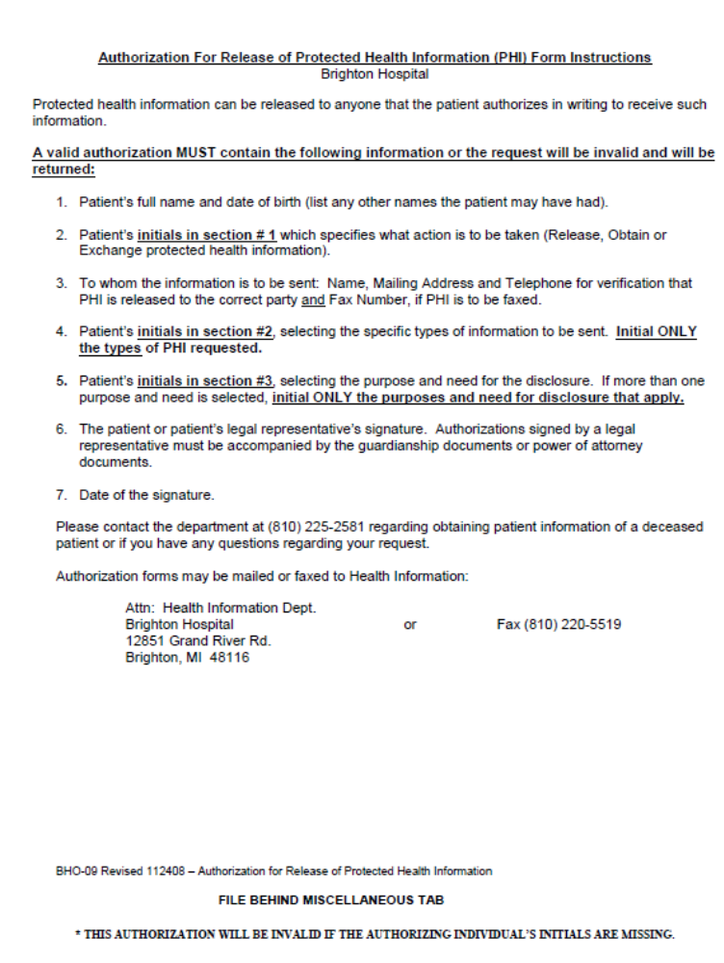

BRIGHTON HOSPITAL
Health Information Fax: 810-220-5519
AUTHORIZATION FOR RELEASE OF PROTECTED HEALTH INFORMATION

I, | Karen Marcetti |  |  |  |  |  |  |  |  |  |  | , DOB: |  |  |  | 12/22/1965 |  |  |  |  |  |  | hereby authorize WILLIAM BEAUMONT HOSPITAL - ROYAL OAK, its
President, Designee or Health Information Services to:
* [Initials Required:]`
1. RELEASE Information To ______ OBTAIN Information From ______
EXCHANGE Information With ______
Name: |  |  | Nancy Bertels |  |  |  |  |  |  |  |  |  |  |  |  |  | Organization: |  |  |  |  | c/o Axiom Requisition Copy Service
Street Address: |  |  |  |  |  |  |  | 2869 Jolly Rd |  |  |  |  |  |  |  |  |  |  |  |  |  |  |  |  | Relationship:
City: |  | Okemos |  |  |  |  |  |  |  |  |  |  |  |  |  |  |  | State: |  | MI |  |  |  |  |  |  |  |  | Zip Code: |  |  | 48864
Phone: |  |  | (877) 886-5090 |  |  |  |  |  |  | Fax: |  |  |  | (517) 886-4116 |  |  |  |  |  |  |  |  |  |  | Other:
I understand that information contained in my health record may include alcohol and drug abuse records protected under 42 Code of Federal Regulations, Part 2; psychological services records, including communications made by me to a social worker or psychologist; and any information regarding communicable diseases and infections as defined by MCLA 333.5131, which includes venereal disease, tuberculosis, HIV, AIDS, and ARC.
I understand that my protected health information (PHI) disclosed under this authorization may be re-disclosed by the individual or organization named above and its privacy may no longer be protected by law.

2. Specific type of information to be disclosed:
* [Initial all types of information that apply to person/organization listed above.]
 |  |  |  |  |  | Discharge Summary |  |  |  |  |  |  |  |  |  |  |  |  |  |  |  |  | Emergency Contact
 |  |  |  |  |  | Medication List |  |  |  |  |  |  |  |  |  |  |  |  |  |  |  |  | AMA Alert
 |  |  |  |  |  | History & Physical |  |  |  |  |  |  |  |  |  |  |  |  |  |  |  |  | Financial/Insurance Information
 |  |  |  |  |  | Admission Assessment |  |  |  |  |  |  |  |  |  |  |  |  |  |  |  |  | Acceptance of Special Deliveries
 |  |  |  |  |  | Treatment Plans and Reviews
 |  |  |  |  |  | Psychosocial Evaluation |  |  |  |  |  |  |  |  |  |  |  |  |  |  |  |  | Admission/Discharge Letter (dates only)
 |  |  |  |  |  | Aftercare Plan |  |  |  |  |  |  |  |  |  |  |  |  |  |  |  |  | Completion of Program Letter
 |  |  |  |  |  | Lab Results and Urine Drug Screen |  |  |  |  |  |  |  |  |  |  |  |  |  |  |  |  | Completion of Benefit Forms
 |  |  |  |  |  | Psychiatric Evaluations & Medication Reviews |  |  |  |  |  |  |  |  |  |  |  |  |  |  |  |  | Other, Specify: |  |  |  |  |  |  | Any and All Records
3. Purpose and need for such disclosure:
* [Initial all that purposes and need that apply to person/organization listed above.]
 |  |  |  |  |  |  | Aftercare Planning |  |  |  |  |  |  | Continuity of Care |  |  |  |  |  |  |  |  |  |  |  |  |  | Emergency
 |  |  |  |  |  |  | Attorney |  |  |  |  |  |  | School |  |  |  |  |  |  |  |  |  |  |  |  |  | Payment of Bill
 |  |  |  |  |  |  | Court/Probation |  |  |  |  |  |  | Family Involvement/Therapy |  |  |  |  |  |  |  |  |  |  |  |  |  | Employer Request/Job Stability
 |  |  |  |  |  |  | Disability/FMLA Benefits |  |  |  |  |  |  | Other – Specify:
4. This authorization may be revoked by me at any time, except in legal action cases, by my written notice to the above named individual or organization, except to the extent that the person or organization that is to make the disclosure has already taken action in reliance on my authorization.
5. This authorization is effective on the date below and will expire in 6 months if not previously revoked by me in writing.
6. Brighton Hospital will not condition treatment, payment, enrollment or benefit eligibility on my signing this document.
7. I am voluntarily signing this authorization and understand what information is going to be released to the above named individual or organization. A copy of this authorization will be provided to me at my request.
 |  | Patient Signature |  |  |  |  |  |  |  |  |  |  |  |  |  |  |  |  |  |  |  |  |  | Date
 |  | Parent/Legal Representative |  |  |  |  |  |  |  |  |  |  |  |  |  |  |  |  |  |  |  |  |  | Date
 |  | Witnessed by |  |  |  |  |  |  |  |  |  |  |  |  |  |  |  |  |  |  |  |  |  | Date
BHO-09 Revised 112408 – Authorization for Release of Protected Health Information FILE BEHIND MISCELLANEOUS TAB
* THIS AUTHORIZATION WILL E INVALID IF THE AUTHOIZING INDIVIDUAL’S INITIALS ARE MISSING.

Order No. 01-12345 -003

